**ASSIGNMENT ON INFORMATICA**

1. **Assignment – 01: Design job to read 3 tables from SQL Server (Emp, Dept, Loc) and load into one SQL server.**

**Designer:**

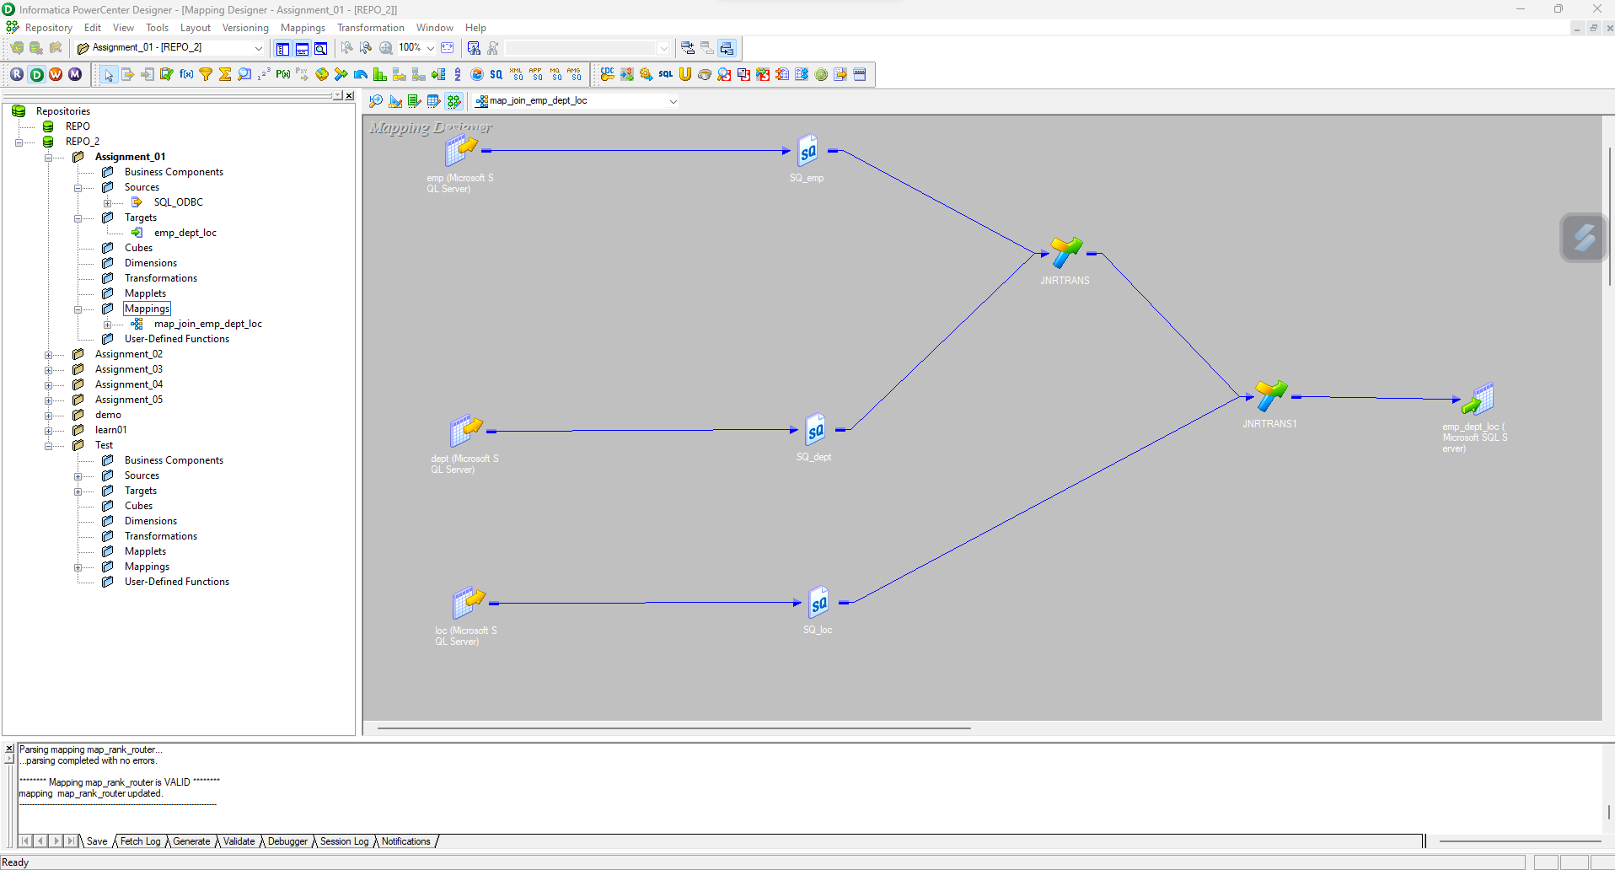

**Workflow:**

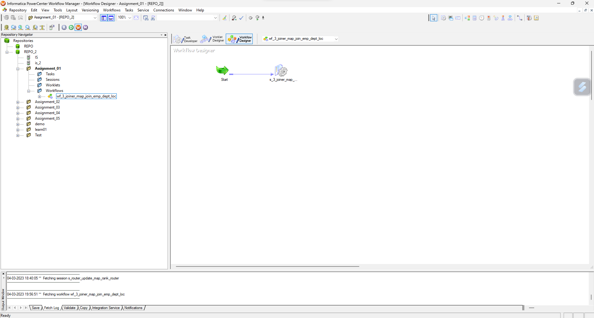

**Workflow Monitor with run properties:**

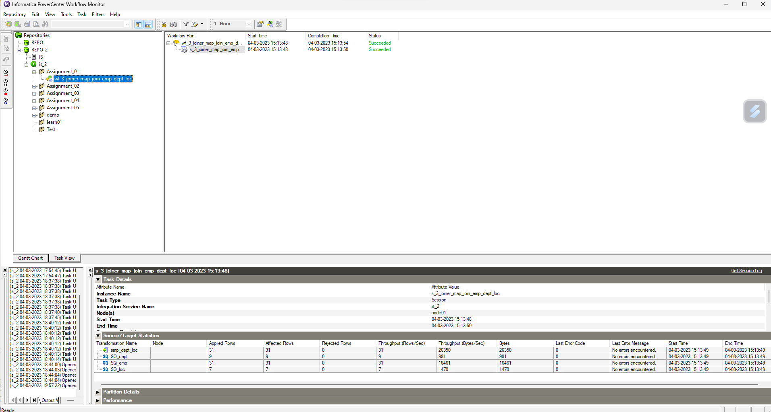

**Database:**

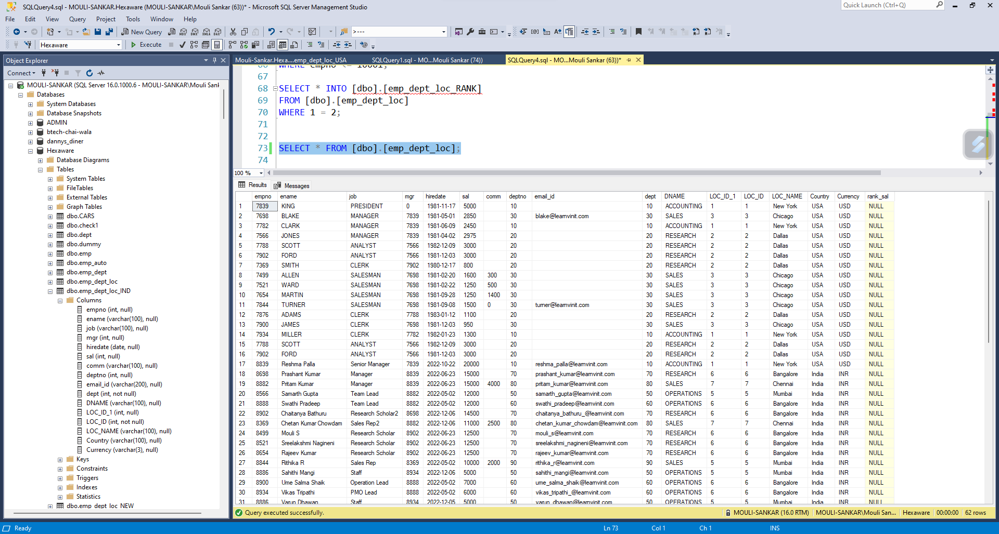

1. **Assignment – 02: Use Sequence Generator in Assignment – 01, and update emp_no starting from 5000 increment by 100 in the target table.**

**Designer:**

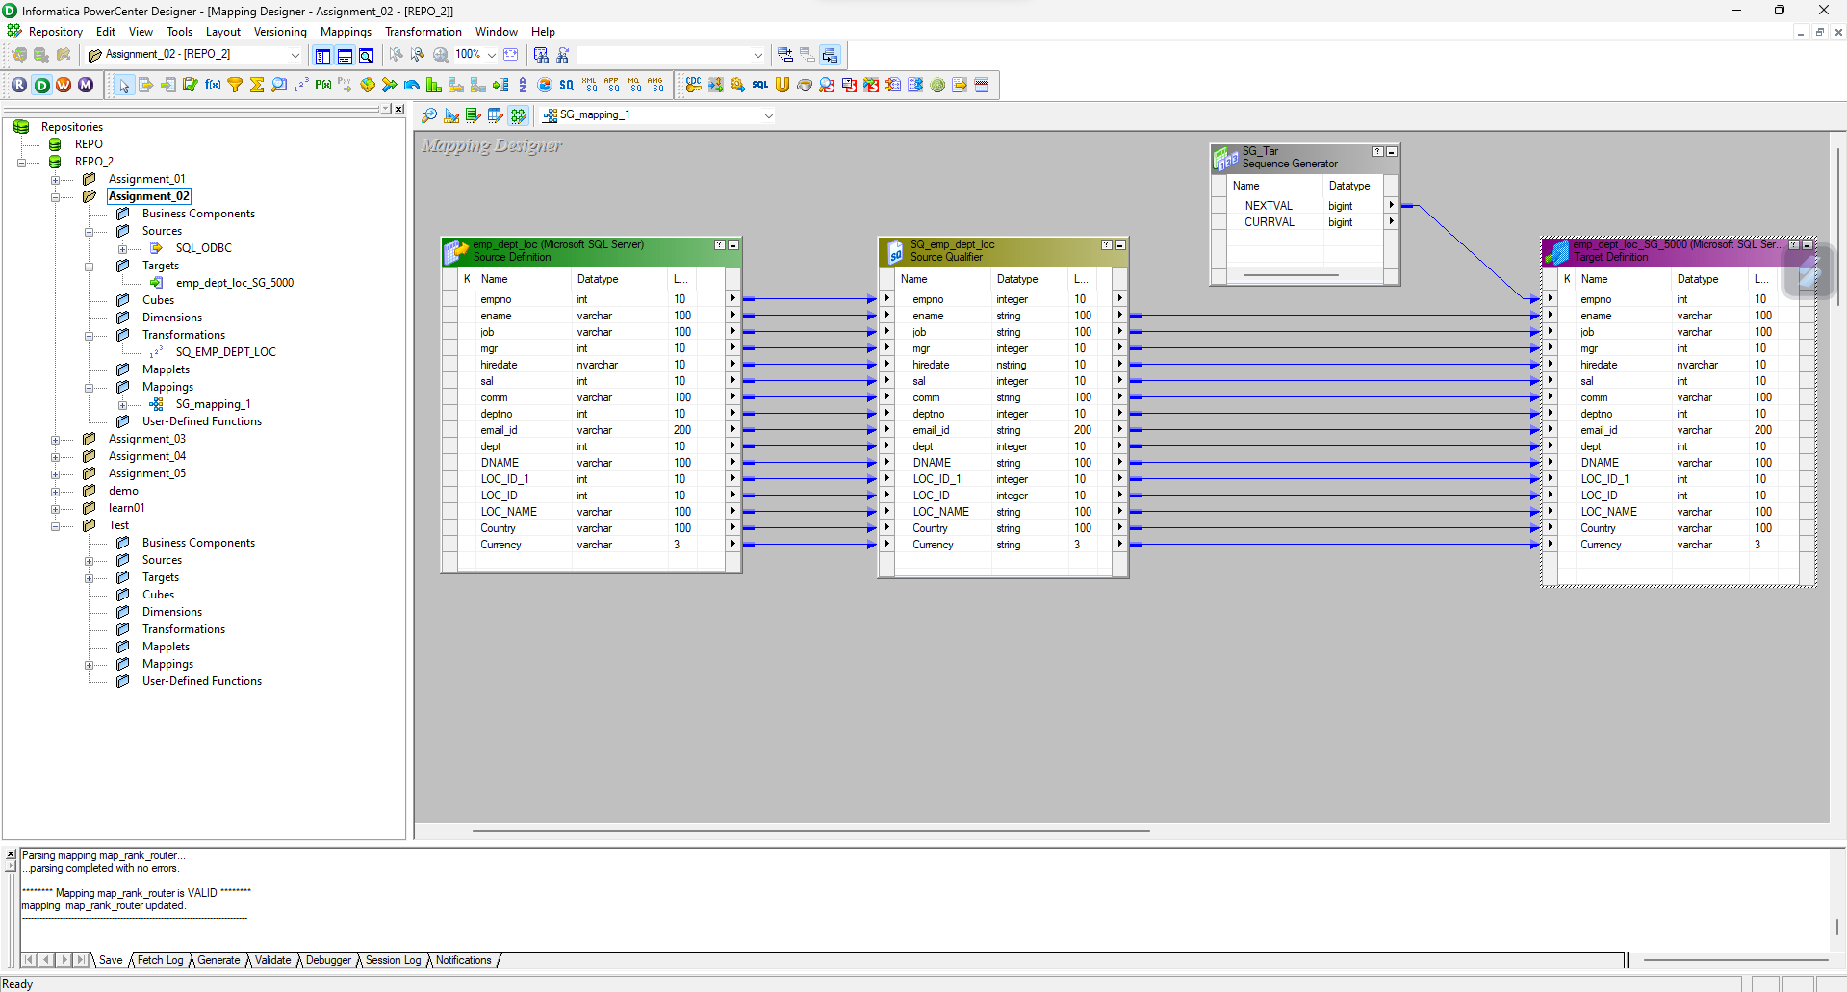

**Workflow:**

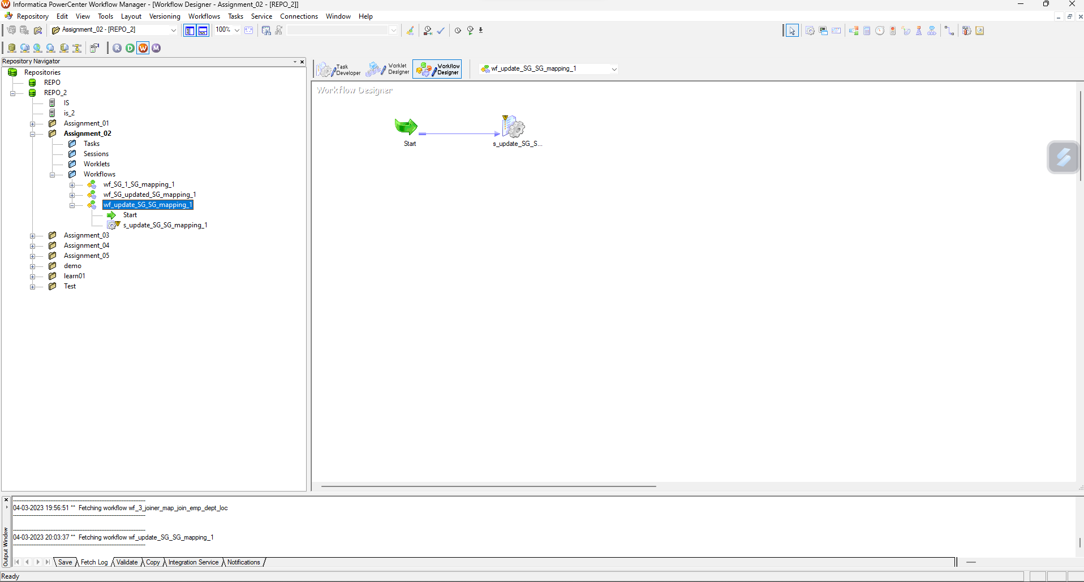

**Workflow monitor and run properties:**

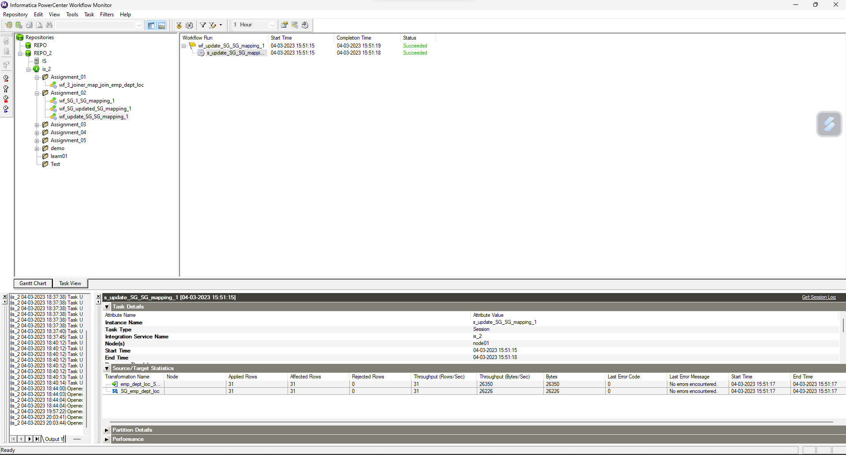

**Database:**

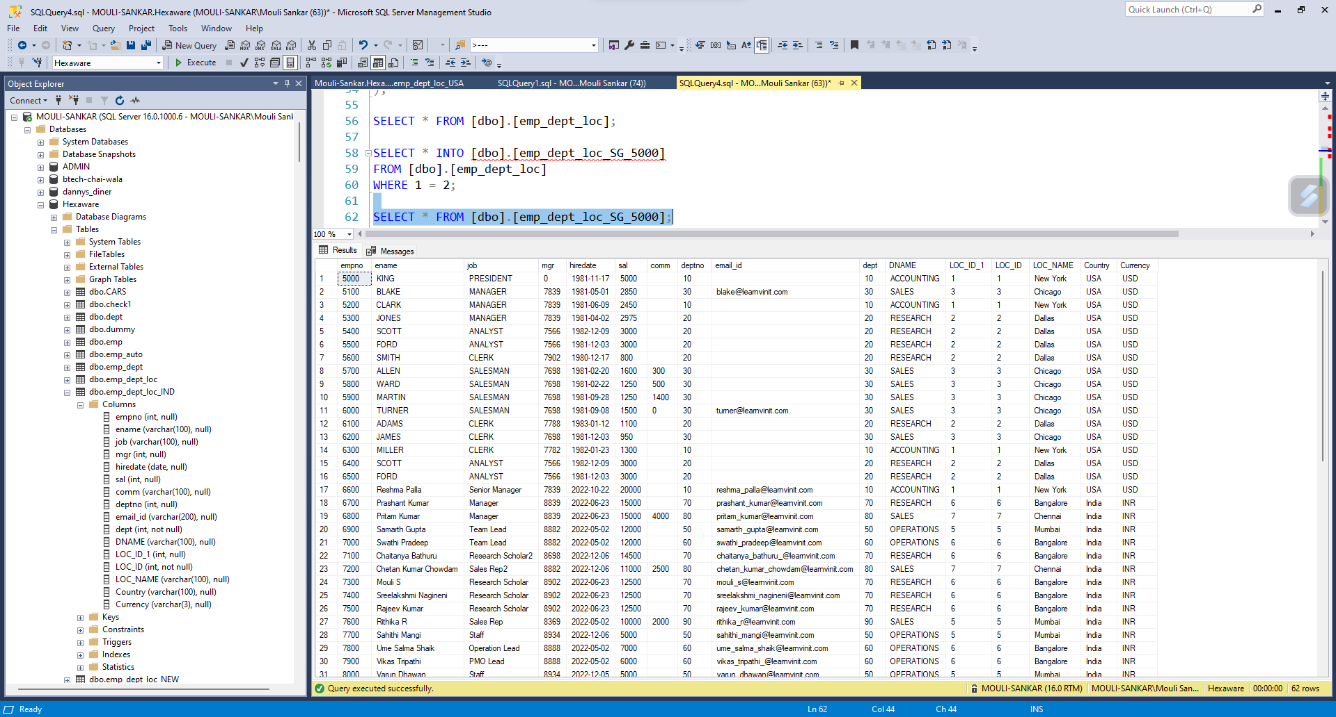

1. **Assignment – 03: Using Assignment – 01, Rank Salary in new target table.**

**Designer:**

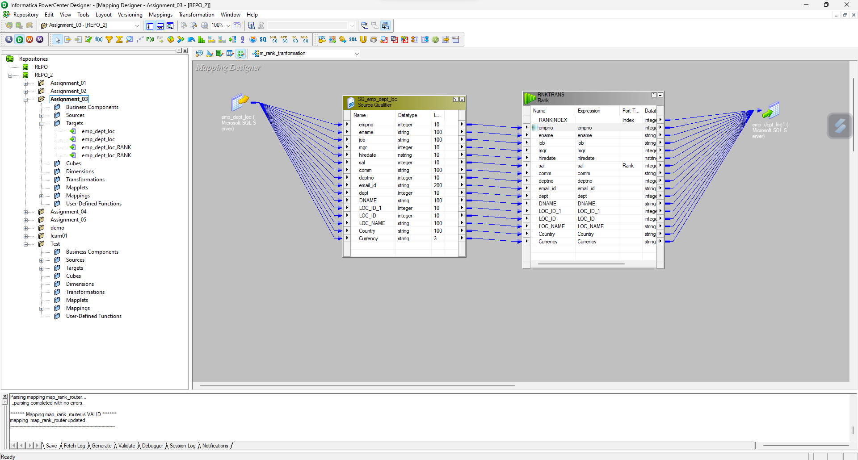

**Workflow:**

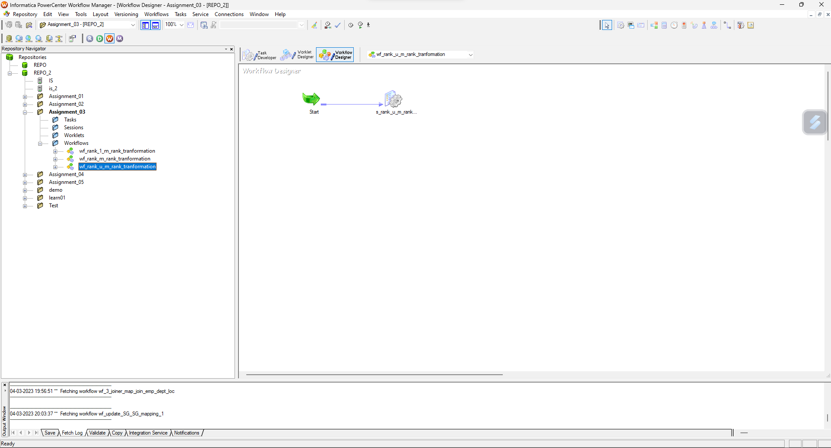

**Workflow Monitor and run properties:**

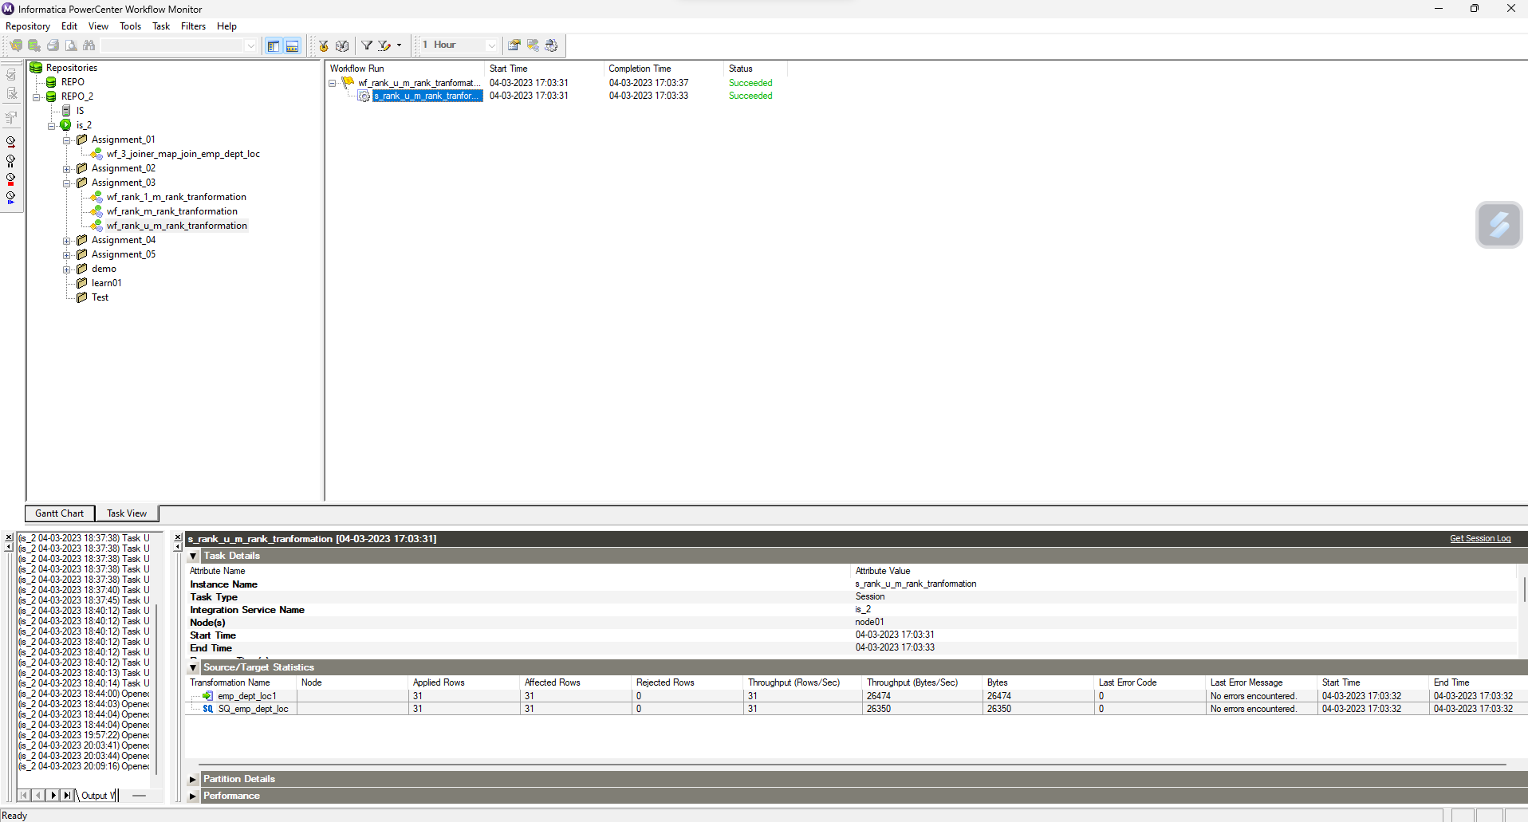

**Database:**

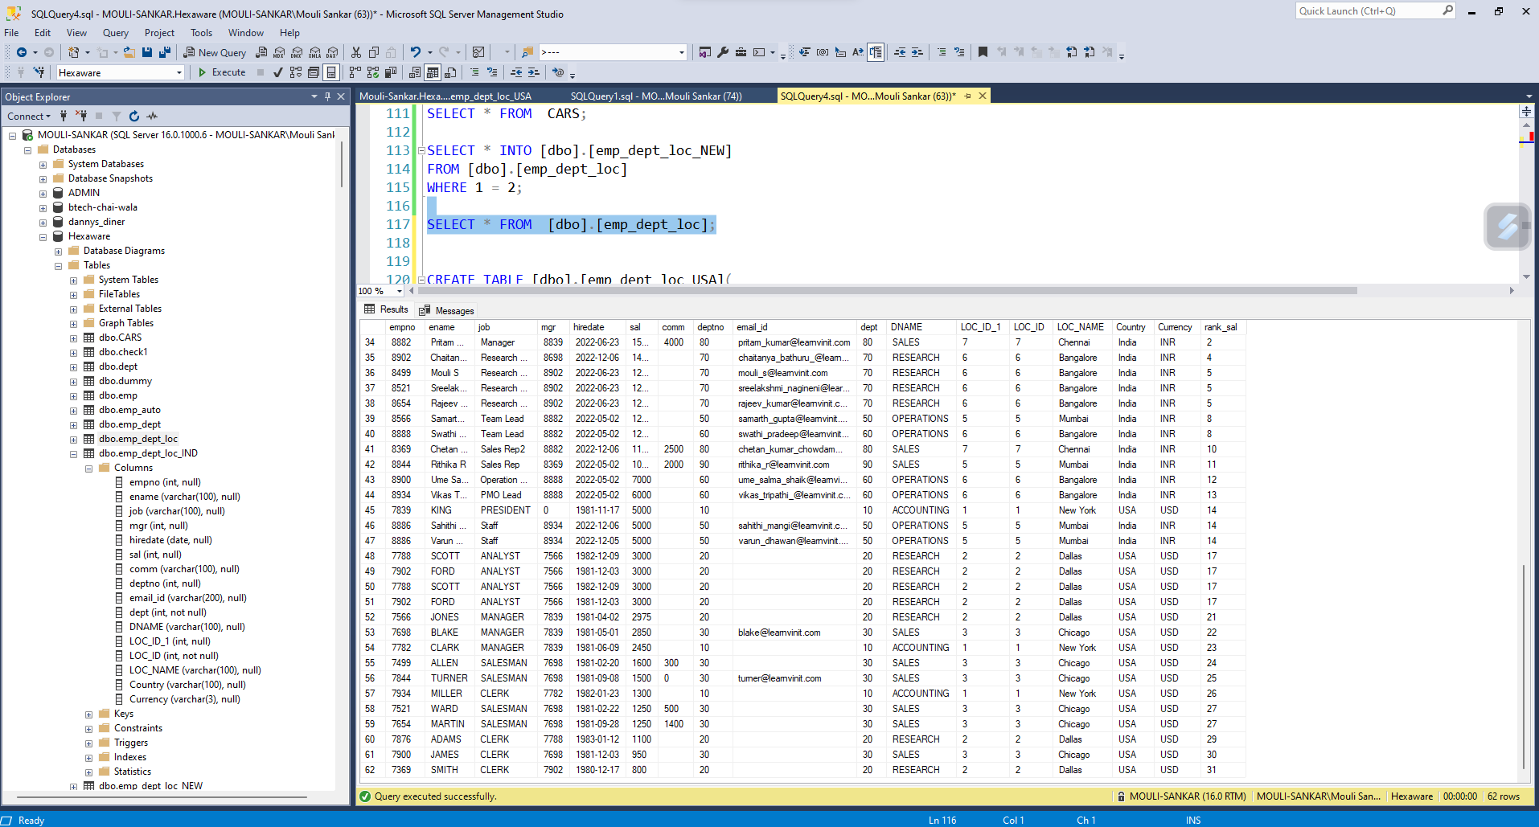

1. **Assignment – 04 : Using file as data source and target as SQL server, create job to read emp details from .csv file and load into sql server database table.**

**Designer:**

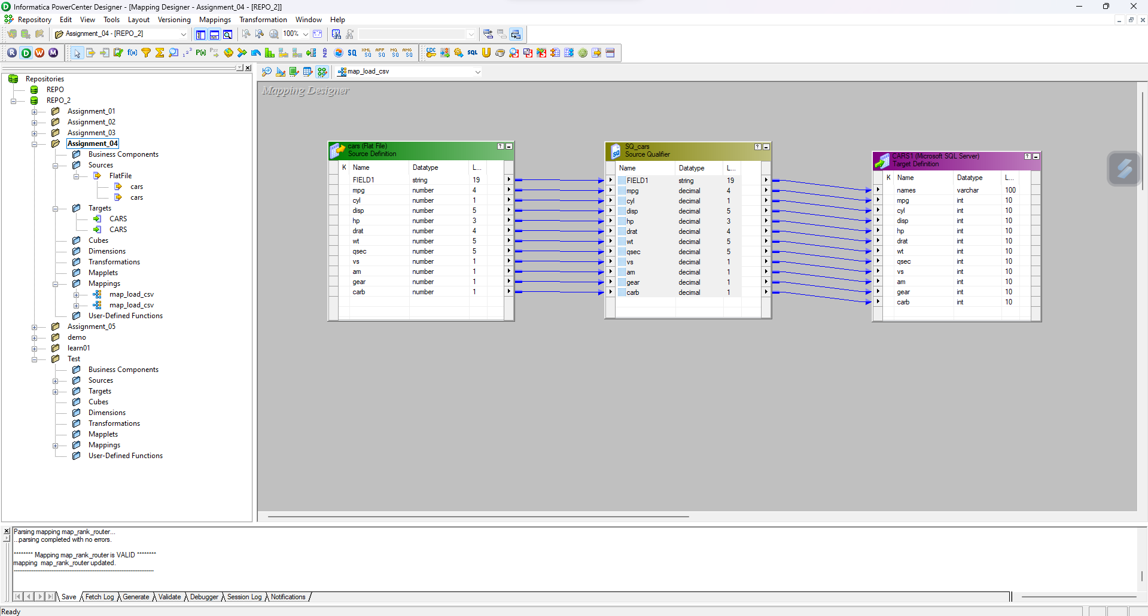

**Workflow:**

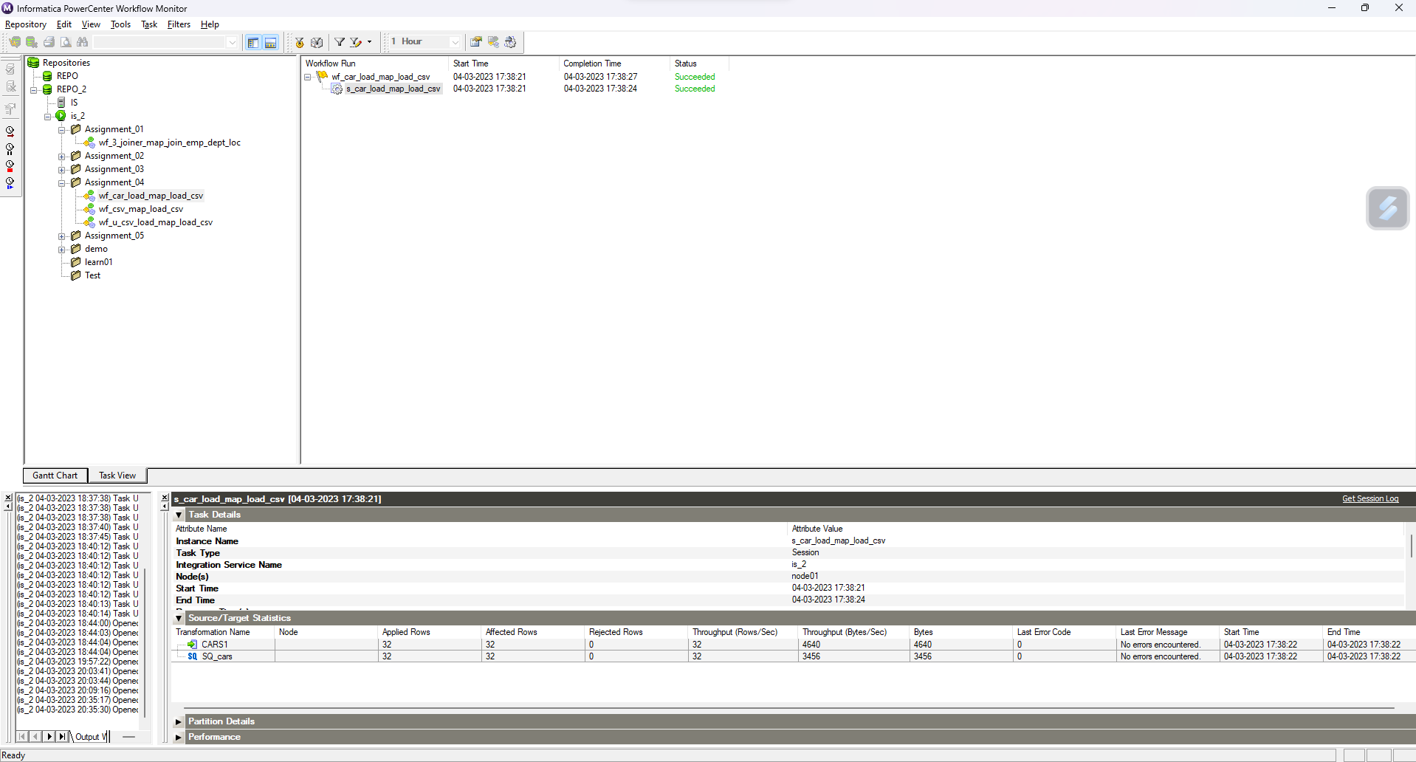

**Workflow Monitor and run properties:**

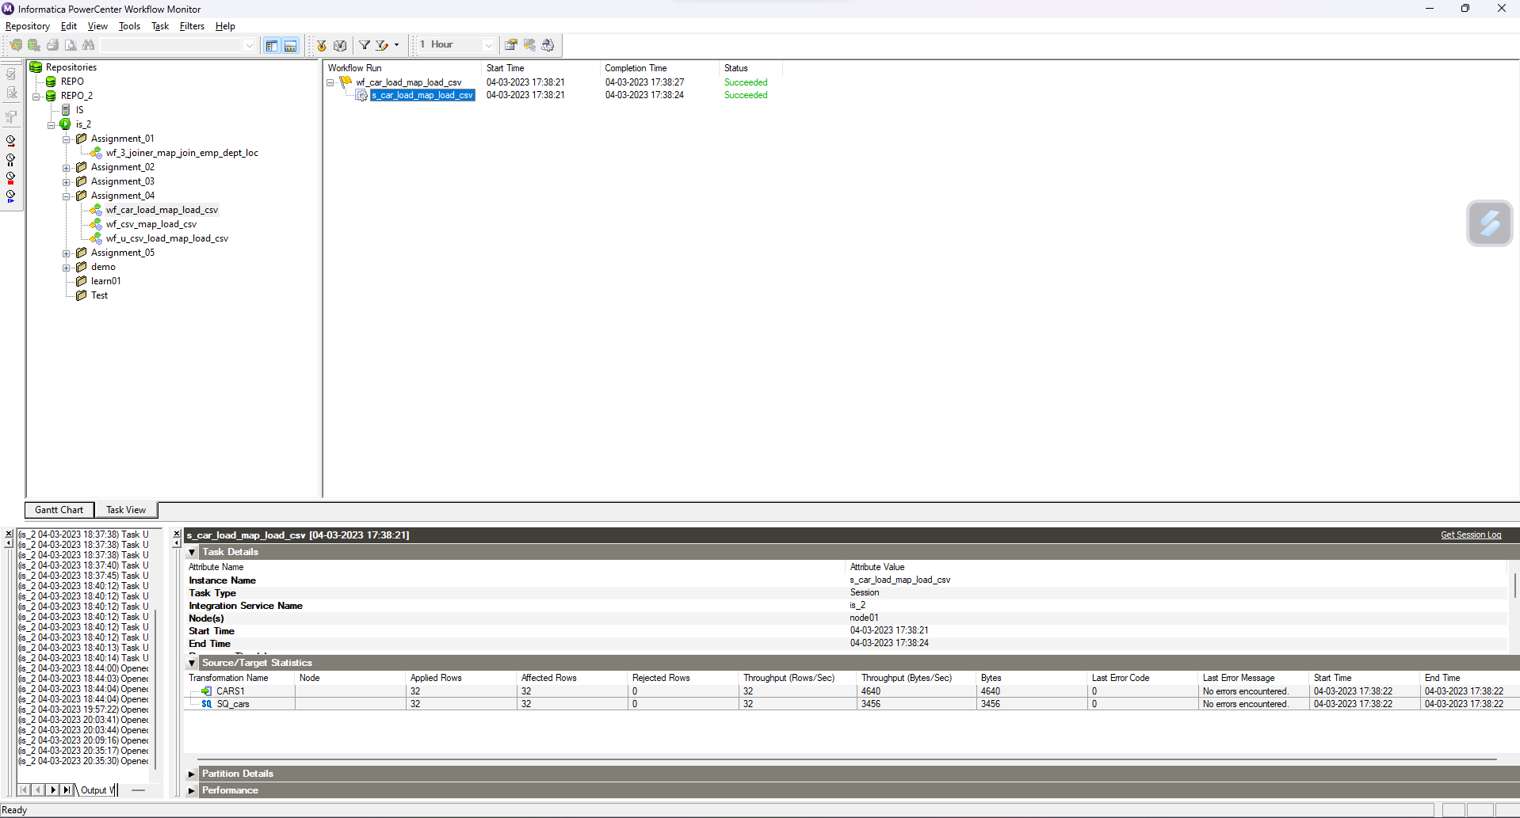

**Database:**

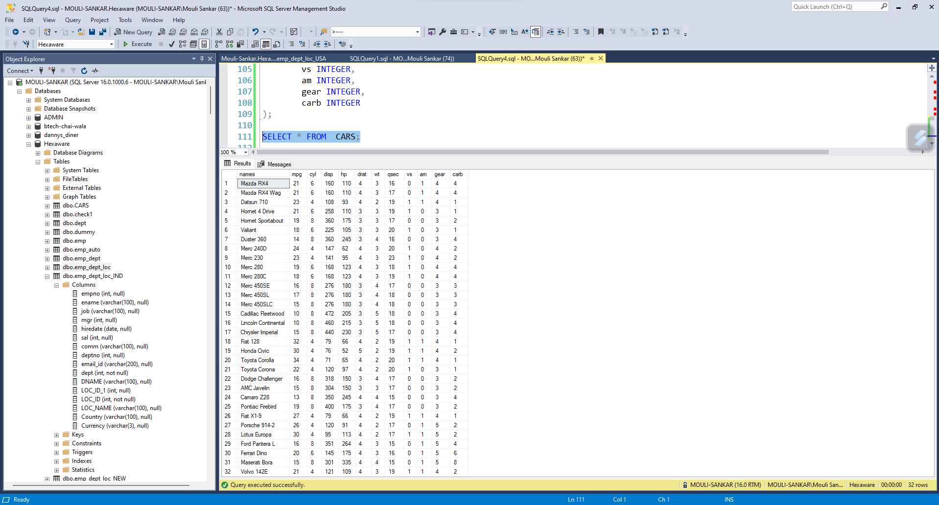

1. **Assignment – 05: Using Router and Rank split India and US employee from Loc table and rank their salary in 2 different tables.**

**Designer:**

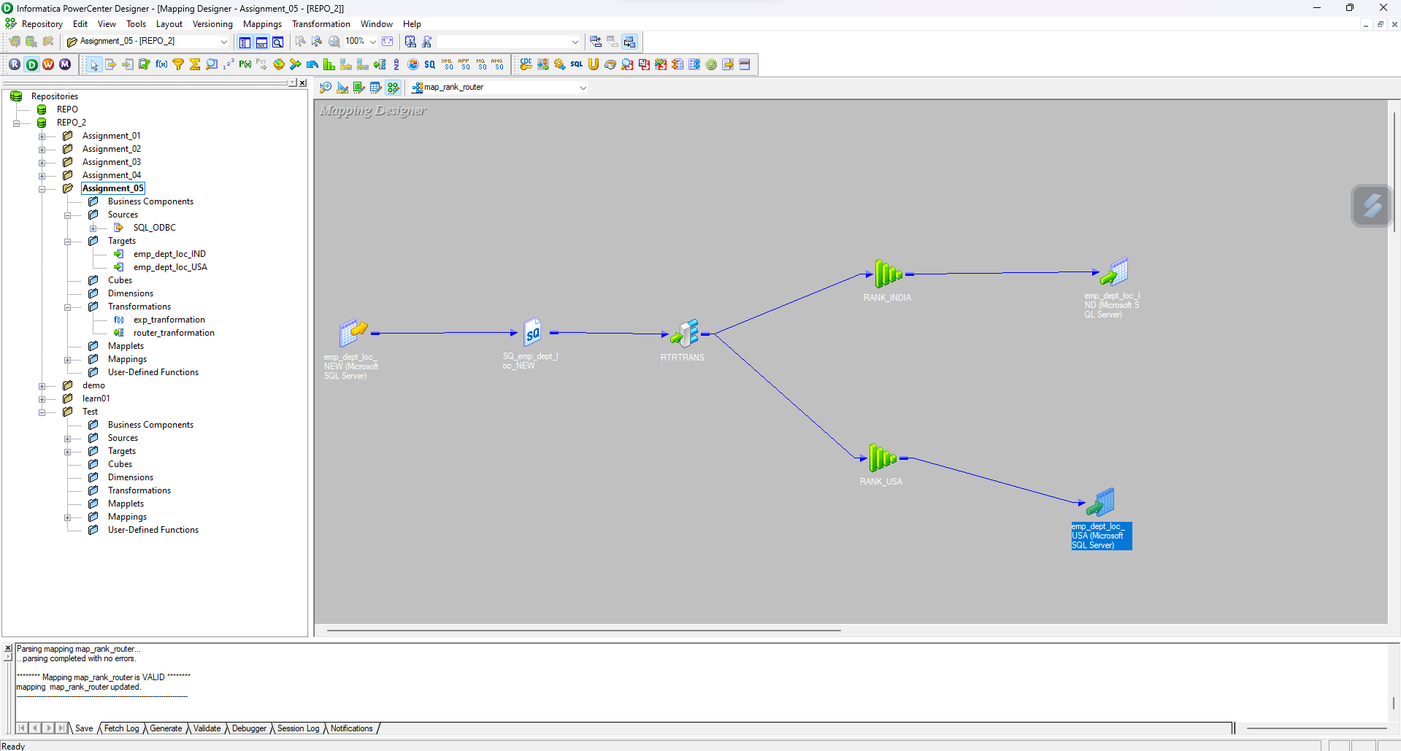

**Workflow:**

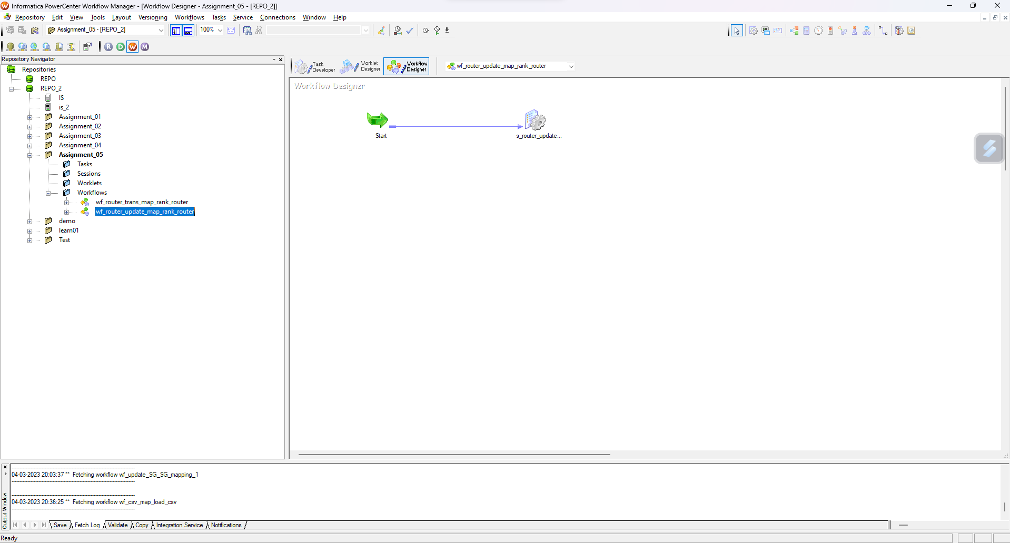

**Workflow Monitor and run properties:**

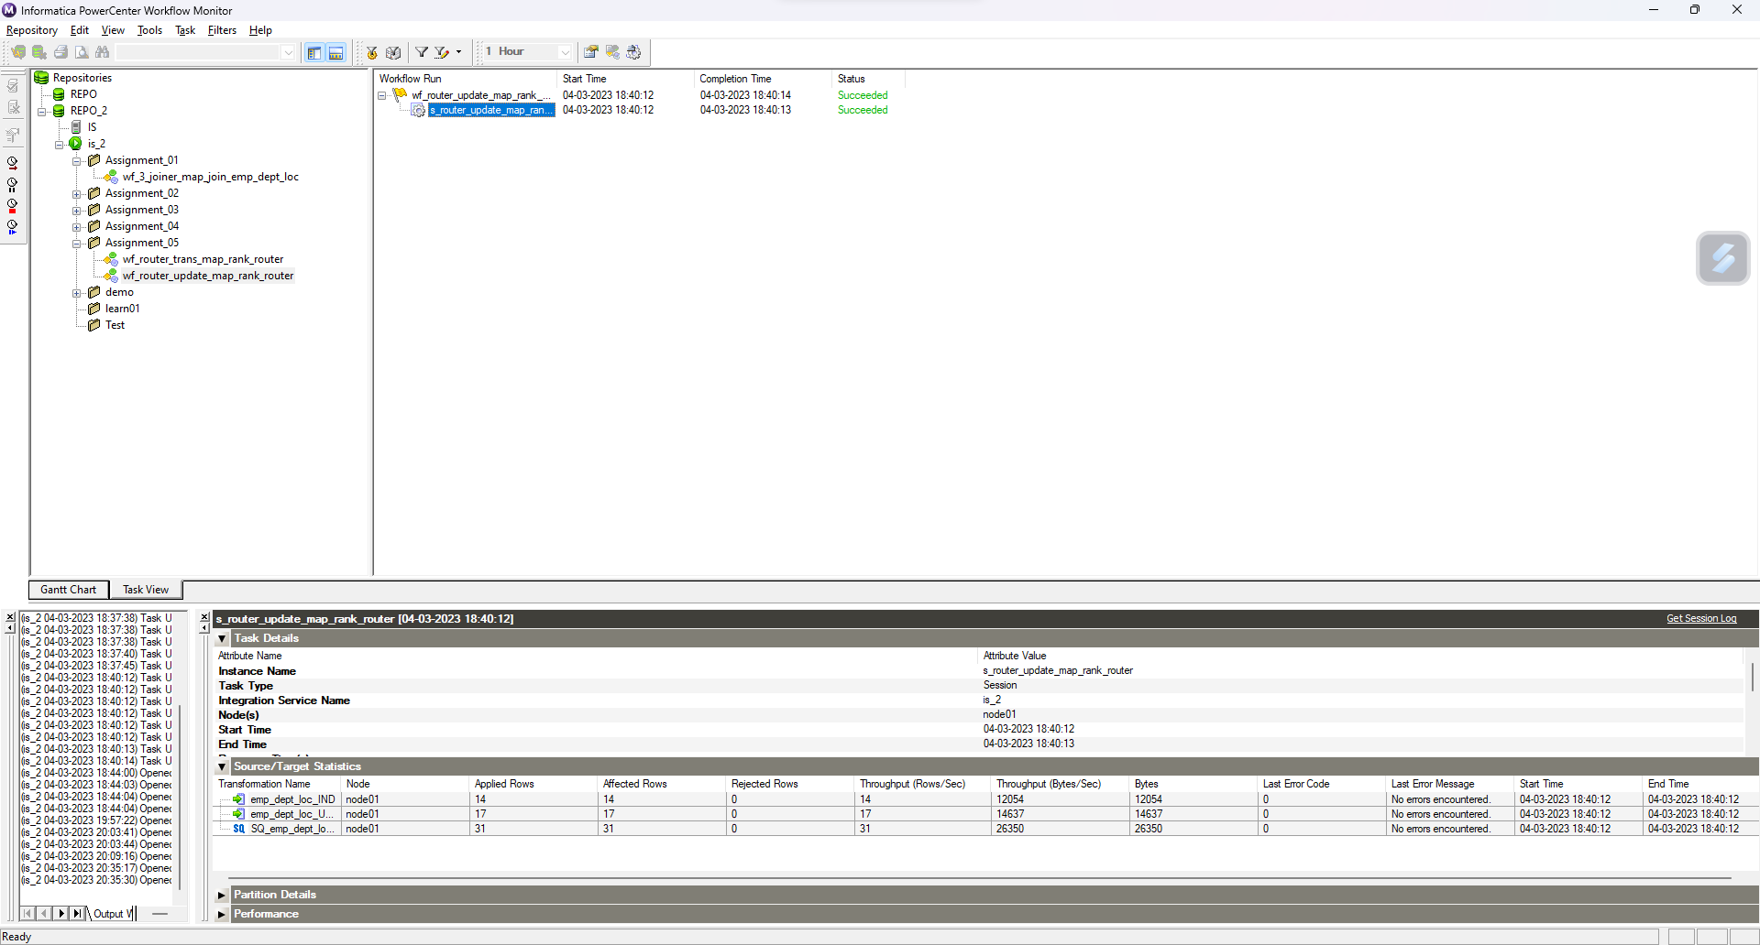

**Database:**

**India Table:**

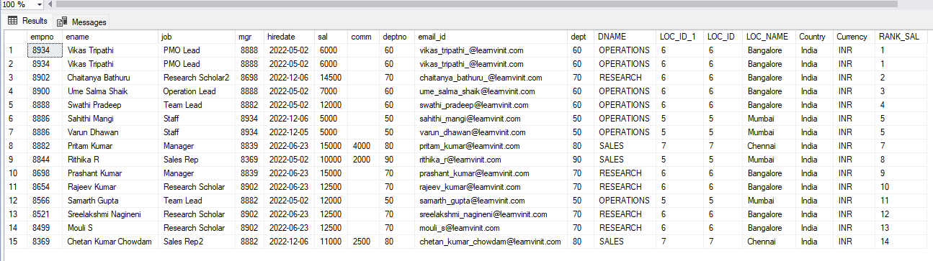

**USA Table:**

